
Annual Progress Report Format

The following format and information should be included in the annual progress report

Basic data/Summary

Date of submission | 30/12/2020
Benefiting country and location | Nigeria
Title of the programme | Transitioning from Humanitarian Relief to Long Term Development: Addressing the Herdsmen-Farmers Conflict in Nigeria (Peace Project)
Duration of programme | From 15/10/2018 to 14/10/2021 (36 months)
Lead UN organization | United Nations Development Programme  (with overall coordination from the Resident Coordinator’s Office, UN System in Nigeria/Resident Representative, UNDP)
Implementing UN organization(s) | UNDP  Resident Representative,  Mr. Mohamed Yahya (mohamed.yahya@undp.org)  Focal Officer: Kehinde Osotimehin (kehinde.osotimehin@undp.org)  Focal Person (Finance): Sunday Adeleke (sunday.adeleke@undp.org)  UNHCR  Country Representative,  Ms. Chansa Kapaya (kapaya@unhcr.org)  Focal Officer: Charles Saleh (salehc@unhcr.org)  FAO  Country Representative,  Fred Kafeero (fred.kafeero@fao.org)  Focal Officer: Suleiman, Abubakar (Abubakar.Suleiman@fao.org)
Non-UN implementing partners | Benue State Government
Total programme budget including indirect support costs in US$ | US$ 5,440,153.60
Amount requested from the UNTFHS in US$ | US$ 2,001,841.60
Amount to be sourced from other donors in US$ (please list each donor and the amount to be contributed) | Total US$ 3,438,312, of which:  - UNDP $1,537,294.00  - UNHCR $1,529,498.00  - FAO $295,200.00 (technical support)  - Benue State Government $76,320
Reporting period | 15 October 2019 – 31 October 2020
Type of report | Second Annual Report

Executive Summary

“The Transitioning from Humanitarian Relief to Long-term Development: Addressing the Herdsmen-Farmers Conflict in Nigeria” project seeks to contribute to ending the Herdsmen-Farmers Conflict in Benue and Nasarawa States in Nigeria. Using the United Nations human security approach, the project is making progress towards enhancing the ability of affected communities to identify and mitigate risks and threats while ensuring that there is no interruption in livelihoods and productive activities; implementing targeted initiatives to promote farming and livestock activities and establish synergies between these industries; establishing a state peace architecture; local peace committees in conflict-affected LGAs to foster dialogue and non-violent resolution of disputes, reconciliation, co-existence and social cohesion; and mobilizing national and regional efforts in the promotion of human security at national and sub-regional levels.

The overall project contributes to the United Nations Sustainable Development Partnership Framework (UNSDPF) Outcome 2: Humanitarian Response, Peacebuilding and Security: By 2022, citizens coexist peacefully, enjoying increased resilience, higher State capacity for humanitarian response, and reduced incidence of armed and violent conflicts in the country and cross border.

The project is jointly implemented by UNDP, UNHCR, and FAO under the Delivery as One (DaO) methodology, in close partnership with the Benue State Government. Using complementary expertise, the project is implemented by UNDP, UNHCR and FAO support, with UNDP as lead agency.
The objectives of the project are: (a) reduce the vulnerability of affected persons through community-based protection by enhancing ability of affected communities to identify and mitigate risks and threats while ensuring that there is no interruption in livelihoods and productive activities; (b) support livelihood and empowerment of community members through targeted initiatives to promote farming and livestock activities and establish synergies between these industries; (c) prevent violent conflicts and build peace by establishing a state peace architecture; local peace committees in conflict-affected LGAs to foster dialogue and non-violent resolution of disputes, reconciliation, co-existence and social cohesion; (d) mobilize national and regional efforts in the promotion of human security at national and sub-regional levels.

The expected The project expected outputs are: Community Protection Interventions implemented in five target Local Governments; Livelihood and Economic Empowerment provided for farmers and livestock breeders; Functional Peacebuilding Architecture established at the state and community levels and National and Regional Framework for addressing Herdsmen-Farmers Conflict established.

The project experienced some challenges based on the delays in activity implementation for 6 months due to a nationwide lockdown to mitigate the spread of COVID-19. There was a delay in utilising the land for livelihood empowerment activities through agriculture and building of homes for IDPs which led to encroachment by locals who used part of the land for crop farming. We had limited funds because the UNDP counterpart funding has not been provided due a downturn in UNDP’s finances. There was a community youth agitation for compensation on government allocated land for the Project. There were also security challenges in the LGAs where the project is being implemented which sometimes limits access or requires costly security measures to be taken to gain access. Finally, the Project Team experienced difficulty with fully engaging with the herdsmen as required because they are mostly unavailable for the larger part of the reporting year. Internal issues of the MACBAN prevented them from fully participating in the project and its activities.

The Project Team recommends that proper coordination and effective communication will enable good professional relationships among the agencies. Regular meetings and circulating of weekly update reports will continue to be undertaken by the Project Team and this practice will be maintained throughout the project lifespan. Continuous and effective communications and feedback to Government stakeholders has ensured that the project team, stakeholders and beneficiaries are on the same page. Although community engagements were limited in the reporting period due to the COVID 19 Pandemic however more frequent monitoring visits to the project sites are required for high quality results and to record human-interest stories.

Lessons learnt include the importance of bringing together comparative advantages of agencies i.e. multi-agency implemented projects are quite different in implementation yet extremely effective for quality delivery. This has been demonstrated where Agencies contribute their comparative advantage in unique areas and support each other to produce high quality results. Secondly, the importance of continuous government engagement through Government buy-in and constant feedback has been very helpful to implementing the project, and to avoid uncertainties and lastly, the importance of community trust building with frequent communications with community stakeholders has proved helpful in building and sustaining trust which in turn fosters a conducive environment for project implementation.

Progress to Project Outputs:

Output 1: Community Protection Interventions Implemented in Five Target Local Governments: The community-based Protection Action Groups (PAGs) formed from the onset of the project have served as the platform to champion the prevention of conflict and violence, specifically the conflict between the farmers and the herdsmen and sexual and gender based violence in the communities through advocacy and sensitisation. The PAGs report on a weekly basis, incidents and threats of conflicts and violence at community level to the project team; and cases are reported to security agencies within the communities and the Office of the Security Adviser to the Benue State Government.

As part of the efforts to address conflict between farmers and herdsmen, the Peace Forum made up of the stakeholders such as relevant Ministries, Departments and Agencies of the Benue and Nasarawa State Governments, Development Partners with similar interests, Farmers’ Association, Herders’ Association, CBOs and NGOs etc. in Benue and Nasarawa States holds regular meetings to deliberate on areas that will foster peaceful coexistence among farmers and herders.

Shelter construction with 80 housing units is ongoing and at completion stage as at the date of reporting. The homes for IDPs will cater to the issues of health, safety and accommodation which ensures beneficiaries live in dignity.
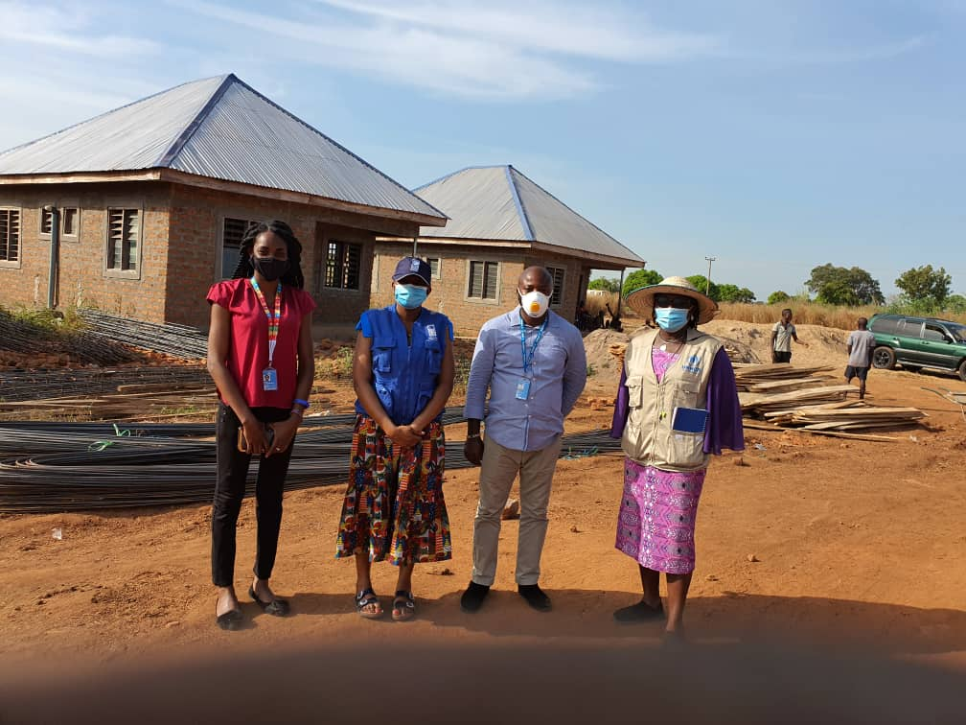
SHELTER CONSTRUCTION WITH 80 HOUSING UNITS AT THE PEACE SETTLEMENT IN GUMA, GBAJIMBA, BENUE STATE
Picture taken in November 2020, by Project Team.

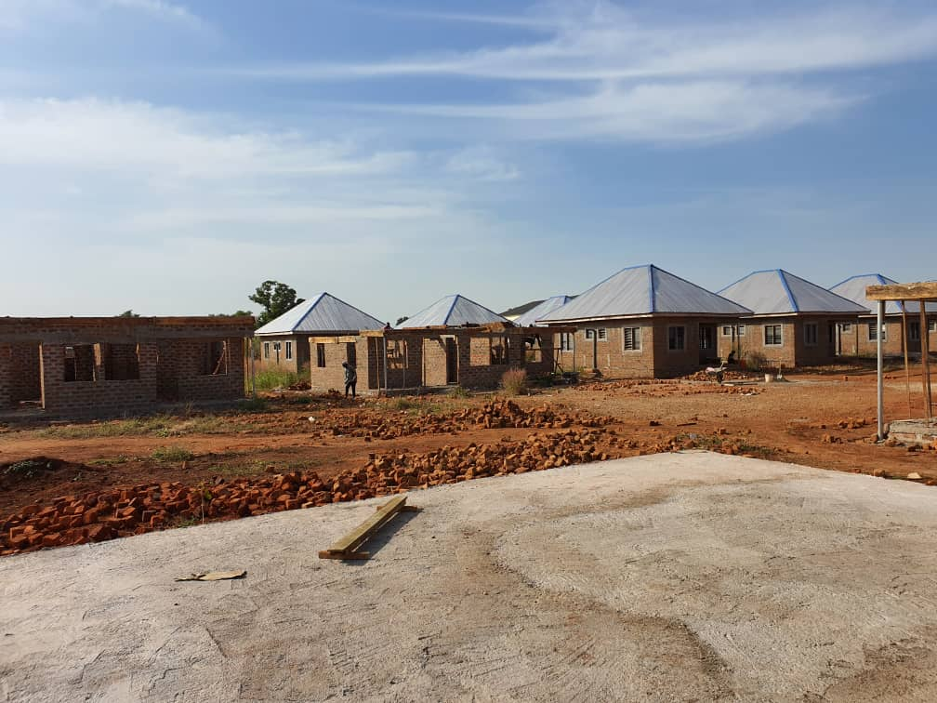
THE PEACE SETTLEMENT IN GUMA, GBAJIMBA, BENUE STATE
Picture taken in November 2020, by Project Team.

Output 2: Livelihood and Economic Empowerment provided for Farmers and Livestock breeders: The project implemented a vocational training for 200 beneficiaries across the 5 LGAs. The project team enrolled 200 beneficiaries for the year 2020 and an additional 200 beneficiaries for the year 2021 to achieve the project target of 400 persons to benefit from the livelihood support scheme Participants, consisting of IDPs and locals, have been profiled to participate in farming activities on about 165 ha of 402.21 ha of land allocated by the Benue State Government across the 5 Focal LGAs for project use, with seeds and farm tools to be made available for them. Demarcation of the land has been concluded, and the boreholes have been established to facilitate access to water for farming activities and domestic use. A total of 120 profiled IDPs will benefit from the livelihood support scheme, in addition to all the members of the host communities. Due to COVID-19 pandemic, there was a delay in the implementation of the vocational skills livelihood programme and a reduction of target beneficiaries to be reached in the reporting year. This was in a bid to comply with the COVID 19 guidelines on social distancing and decongestion of training centres.

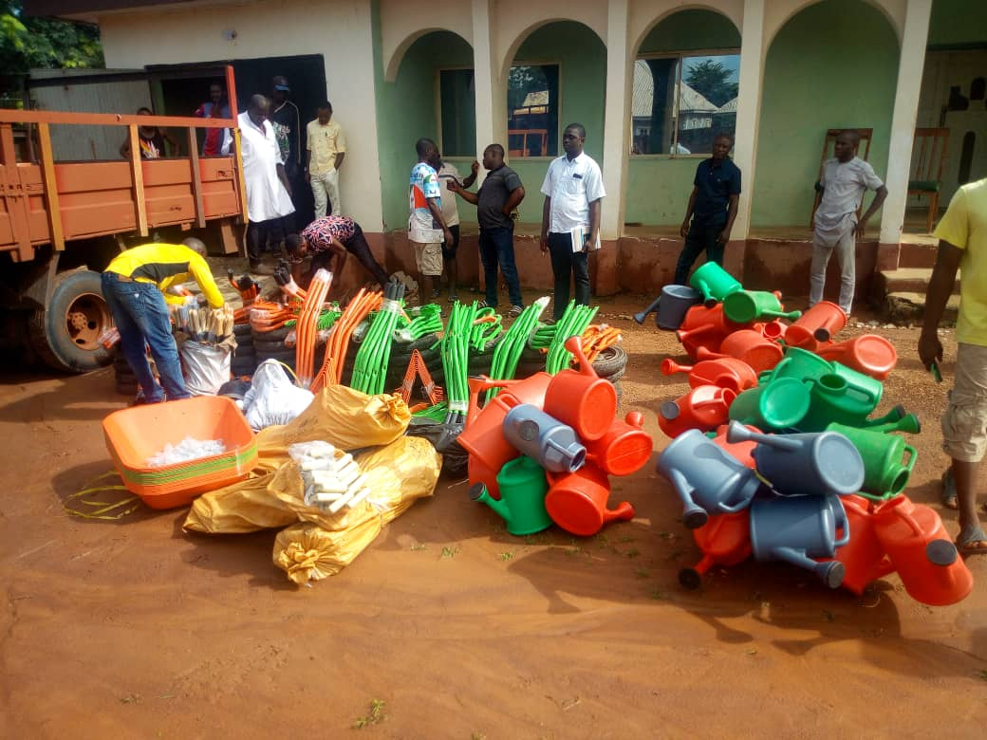
FARM TOOLS FOR IDPs IN BENUE STATE
Picture taken in November 2020, by Project Team.

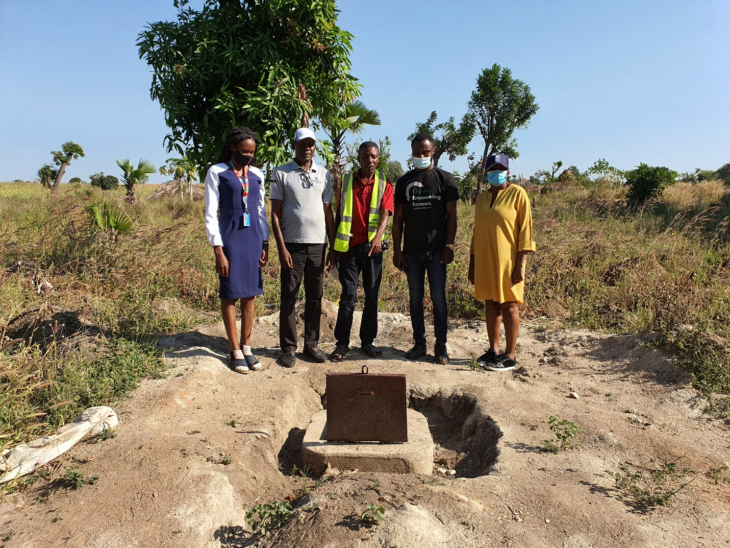
BOREHOLES CONSTRUCTED TO FACILITATE ACCESS TO WATER FOR FARMING AND DOMESTIC USE.
Picture taken in November 2020, by Project Team.

Output 3: Functional Peacebuilding Architecture established at the State and Community levels: In order to understand potential conflicts and how to prevent, manage or resolve them, the project engaged and trained the PAGs to report and resolve conflicts to prevent violence. The project has also engaged a Consultant to develop an ICT Based Early Warning and Early Response System (EWERS), in Benue and Nasarawa States. The EWER Application has been developed and tested in Benue and Nasarawa States. Currently, reports of security concerns in the communities, as received from the community members by the PAGs, are transmitted to the project team and relevant State Government officials for necessary action. Subsequently, once the EWERS is fully established, the PAGs and community members’ reports will be channelled through the EWERS to government staff in the EWERS control rooms, for necessary action.

Output 4: National and Regional Framework for addressing Herdsmen-Farmers’ Conflict established: While this activity is planned for the last year of the project, the relevant national and local laws, and the ECOWAS Protocol have been identified in preparation for a regional conference to develop a well-coordinated people-centred transhumance practice as part of the larger herdsmen-farmers framework for peaceful coexistence. However, there are considerations for a virtual conference, in case it remains unsafe to gather a large crowd physically, to attend. Otherwise, the conference will be scheduled to hold in year 2022, preferably in the second quarter. These propositions will be tabled at the appropriate fora for discussion and agreement

Current Programme Impact:

- Stakeholder Consultation on the Early Warning Early Response System (EWERS): Benue State Sustainable Development Goals (SDGs), in conjunction with the Benue State Planning Commission (BSPC) and the UN project team organized a one-day presentation to key stakeholders on the EWERS. The meeting was attended by various stakeholders including the Federal Road Safety Commission, Nigeria Security and Civil Defence Corps, Miyetti Allah Cattle Breeders Association of Nigeria (MACBAN), the Federation of Female Lawyers, the Benue State Emergency Management Agency, Foundation for Justice, Development and Peace and Mercy Corps. The presentation introduced the EWERS and its functions. The knowledge of the EWERS has been stepped down at the community level to the PAG members and it has been received with high interest and high expectations that the system will complement government efforts to help reduce the recurrent farmer herdsmen crisis. The impact of the stakeholder engagement is that the Benue and Nasarawa Governments have demonstrated support by committing to provide secure accommodation which will serve as the Early Warning Early Response Control Room, to nominate staff to be seconded to work at the EWER control room permanently, provide equipment and furniture required for the EWER Control Room including generators, air conditioners, office furniture, constant supply of electricity and internet connectivity to ensure that the EWER system will be up and running seamlessly.

Livelihood Support Scheme: 200 IDPs have been empowered to be self-sufficient across the ten target communities in tailoring, hairdressing, baking, knitting, welding and soap making. Breakdown of beneficiaries according to skills and locations is shown below.
SKILLS | MOON | YAAV | AILA | USHA | MBAYA | BINEV | DAUDU | GBAJIMBA | TOMBO | TSWAREV | TOTAL
Tailoring | 18 | 16 | 16 | 11 | 15 | 14 | 15 | 13 | 20 | 16 | 154
Hair dressing |  |  | 2 | 6 | 3 | 6 | 3 | 3 |  | 2 | 25
Baking | 1 |  | 1 |  | 2 |  |  | 4 |  |  | 8
Welding | 1 | 1 |  |  |  |  | 2 |  |  | 2 | 6
Knitting |  |  |  | 2 |  |  |  |  |  |  | 2
Carpentry |  | 2 |  |  |  |  |  |  |  |  | 2
Soap making |  |  | 1 | 1 |  |  |  |  |  |  | 2
Barbing |  | 1 |  |  |  |  |  |  |  |  | 1
Total | 20 | 20 | 20 | 20 | 20 | 20 | 20 | 20 | 20 | 20 | 200

In addition, the project team conducted training for economic empowerment through farming activities with farm tools and seeds to be provided and the establishment of solar powered boreholes on the land provided by the Benue State government, for IDP use. The boreholes will provide water for IDP households and support irrigation for dry season farming activities.

Construction of Additional 80 Units of Housing : Construction of 40 blocks of twin housing units is almost completed to accommodate 80 households. Shelter Engineers have been employed to work with the beneficiaries in the building process while the sourcing and payment of artisans is the responsibility of the shelter beneficiaries, following cash disbursements to them. This approach is in the bid to encourage local content, increase earning opportunity for IDPs with skills in construction and related areas. A total of 20 carpenters, 10 masons, 15 water suppliers and 5 IDPs were engaged in the construction activities. The building blocks were sourced from 6 local businesses, the gravel was sourced from 2 local businesses and the sharp sand was sourced from 2 local businesses. It is also intended to foster a sense of ownership, commitment and dignity for the IDPs. The design of the homes ensures security, gender sensitivity and carbon zero compliance.

The Farmer-Herder Peace Forum: The Farmer-Herdsmen Peace Forum continues to hold regular meetings albeit virtually, to provide a strong platform for discussions, negotiations and prevention of conflicts between farmers and herdsmen, and other relevant stakeholders. A WhatsApp group has also been established by members of the Forum to facilitate effective communication, coordination and partnership. A Farmer-Herdsmen Peace Forum was also established in Nasarawa State on 31 August 2020. The platform has given the opportunity to stakeholders and the project team to learn about the dynamics of the conflict and the various efforts of the government and CSOs to resolve them. The Forum has provided a platform for different parties to dialogue and reach consensus on a number of issues for instance the members of the Peace Forum pointed the Project Team towards the direction of the herdsmen, some of whom are still residing in Benue State. The herdsmen had initially exempted themselves from participating in the project activities due to the supposed internal issues and lack of trust of the farmers and the state government. Through the Forum, and with the assistance of the Project Team, these issues have now been resolved. The herdsmen participated at the meeting of the Peace Forum in November 2020 and invited the Project Team to visit and engage with them in the communities, where they reside in Benue State. The planned engagement will usher in the trainings planned for the herdsmen communities.
Monitoring by the Protection Action Groups: Weekly reports are produced and submitted to the project team, the State Project Focal Person and the Office of the Security Adviser to the Benue State Government. Reports are useful to understand the trends of crime and conflicts and the preventive measures. The Project Team is committed to support the State Government to ensure that it is proactive in using received information to prevent and address conflicts.
Mainstreaming Human Security Approach:

The project continues to be relevant, especially with the COVID 19 Pandemic and the resulting human security issues. The project has fully employed the UN’s human security approach to resolve the challenges.

The project implementation plan and process has been PEOPLE-CENTRED, involving all stakeholders at local and state levels. The Community leadership, with guidance from the project team, selected the Protection Action Group members and provide support in maintaining an enabling environment for the project. Regular communication with government and security agencies on emerging security concerns in the communities and the establishment of the EWERS have contributed to the PREVENTION-ORIENTED approach. The Peace Forum accords the project the opportunity for multi-stakeholder engagement for COMPREHENSIVE analysis and strategy evaluation, experience sharing and networking.

While both farmers and herders have been greatly affected by the conflict, their needs are peculiar to their cultural inclinations and lifestyles. Using a CONTEXT-SPECIFIC approach, the livelihood empowerment support was designed to provide vocational skills, crop farming and pasture production, according to the preferences of the beneficiaries. The project has actively promoted PROTECTION AND EMPOWERMENT of the target populations. A total of 450 beneficiaries have been engaged in economic empowerment while the trained Protection Action Group members are also supported in the sensitization of community members on protection issues and advocacies to relevant local and security authorities, as is necessary.

Results
See the attached Results Monitoring Report Template detailing the progress made in the second year towards the project targets.

Progress on Advancement of the Integration and Mainstreaming of the Human Security Approach:
Engagement with Federal Government – The Office of the Resident Coordinator engaged with the Governors in Benue and Nasarawa States to ensure programme support and ownership. The RC also sustained his engagement with the Federal Government through the Vice President’s Office, to ensure effective implementation of the National Livestock Transformation Plan with the principles of the human security.
Partnerships and Coordination -
Nine relevant agencies of government and civil society groups are receiving technical support ,through mentorship and guidance, to respond more effectively to emerging issues amongst displaced persons. They include the Ministry of Women Affairs, SDGs Office, SEMA, Ministry of Education, Nigeria Police Force, Nigeria Immigration Service, international Federation of Women Layers, Foundation for Justice, Development and Peace, and CSOs in Benue (CSO-B Network). Reports are shared with some and they participate in project meetings. The project has leveraged on the work of other organisations such as Thrive Agric, Search for Common Ground, Mercy Corps, Centre for Humanitarian Dialogue, Foundation for Justice, Development and Peace and USAID in the area of livelihood support, economic empowerment and peace architecture.

Awareness Creation and Education – Training was conducted for the Protection Action Group members on protection issues, including SGBV, and members now submit weekly reports to the project team which is transmitted to the relevant government agencies for necessary action. The project team, along with the PAG members, conduct sensitization on Farmer Herdsmen Conflicts, Child Protection, SGBV and Post-Exposure Prophylaxis for rape survivors. The culture of silence around rape is being challenged and the advantages of early reporting are brought to the fore. Anecdotal evidence shows that more community members are willing to report rape cases and receive post-exposure prophylaxis, through referrals. About 20 rape incidents and 38 cases of domestic violence were reported between March and October 2020. Out of the 20 rape cases, 16 survivors were able to access post exposure prophylaxis.
Progress on Facilitating the Scaling Up and Replication of the Programme and its Human Security Approach:
Co-Funding by Benue State Government – Benue State Government under the office of the Sustainable Development Goals (SDGs) supported the project with a well-furnished office valued at $5,000 per annum, over 400 hectares of land valued at over $1.2M for crop farming and shelter construction for the displaced persons, and tractors worth $250,000.
The Benue State Government also provides technical support to respond to conflict issues. They facilitate community engagement, negotiations and payment of government staff allowances during field activities. With the sustained commitment of government, the project team can continue to work effectively and possibly scale-up interventions.
The UN is in discussions with Benue State Government for additional funding support.

Challenges Faced and Lessons Learned
- Challenges faced during the reporting period and mitigation measures

 | Challenges | Mitigation measures
1. | Delays in activity implementation for 6 months due to a nationwide lockdown to mitigate the spread of COVID-19 | Online virtual communication was employed to communicate with staff and stakeholders at different locations.  Project activities were held without physical contact. The Benue and Nasarawa Peace Forums were able to hold virtual meetings.
2. | Delay in utilising the land for livelihood empowerment activities through agriculture and building of homes for IDPs has led to encroachment by locals who used part of the land for crop farming | There were meetings with locals where an agreement was reached, to hand over encroached land to the IDPs and compensation will be made from the harvest, using existing local formulae.
3. | Limited funds: UNDP counterpart funding has not been provided due a downturn in UNDP’s finances. | UNDP’s new senior management have been made aware of the Agency’s financial obligation to this project. There was also a follow up meeting between the UNDP senior management and the HSTF, where UNDP committed to close the gap.
4. | Community youth agitation for compensation on government allocated land for the Project. | Consultations with State and Local Governments, Traditional Leaders and community dialogues have helped in resolving the issues.
5. | Security challenges in the LGAs where the project is being implemented sometimes limits access or requires costly security measures to be taken to gain access. From March to October 2020, a total of 32 herdsmen attacks were recorded, with 63 persons killed, several were injured and displaced. 11 rape and 2 sexual assault cases were reported to have been perpetrated by herdsmen. There is no significant reduction of cases yet especially since the herdsmen are near inaccessible | State government intervened by providing security and reinforcement. The herdsmen will become more accessible in the coming year with the new linkages now established with the herdsmen communities in Benue State.
6. | Difficulty to fully engage with the herdsmen as required because they are mostly unavailable for the larger part of the reporting year. Internal issues of the MACBAN prevented them from fully participating in the project and its activities. | The project team was able to receive the commitment of the MACBAN to commit to the project.  Pending engagements with the MACBAN, the project team was able to identify herding communities in three of the five LGAs through networking and will be working closely with them to achieve the project objectives.

- Lessons learned during the reporting period

 | Lessons learned | Recommendations
1. | Importance of bringing together comparative advantages of agencies: Multi-agency implemented projects are quite different in implementation yet extremely effective for quality delivery. This has been demonstrated where Agencies contribute their comparative advantage in unique areas and support each other to produce high quality results. | Proper coordination and effective communication will enable good professional relationships among the agencies. Regular meetings and circulating of weekly update reports will continue to be undertaken by the Project Team. This practice will be maintained throughout the project lifespan.
2. | Importance of continuous government engagement: Government buy-in and constant feedback has been very helpful to implementing the project, and to avoid uncertainties. | Continuous and effective communications and feedback to Government stakeholders has ensured that the project team, stakeholders and beneficiaries are on the same page.
3. | Importance of community trust building: Frequent communications with community stakeholders has proved helpful in building and sustaining trust which in turn fosters a conducive environment for project implementation. | Community engagements were limited in the reporting period due to the COVID 19 Pandemic. More frequent monitoring visits to the project sites are required for high quality results and human-interest stories.

- Findings from evaluation
No concrete evaluation done in this project year.
Financial Status
Table 1: Financial status
Implementing Organization | Approved budget year 1 (A) | Funds received year 1 (B) | Approved budget year 2 € | Funds received year 2 (D) | Approved budget year 3 € | Funds received year 3 (F) | Total funds received to date  (G=B+D+F) | Expenditure to date (H) | Balance of received funds  (G-H) | Utilization rate  (H/G)
UNDP | 510,165.30 | 510,165.30 | 134,092.40 | 134,092.40 | - | - | 644,257.7 | 358,830.06 | 285,427.64 | 55.7%
UNHCR | 496,258.86 | 496,258.86 | 378,002.46 | 378,002.46 | - | - | 874,261.32 | 868,340.08 | 5,921.24 | 99.3%
FAO | - | - | - | - | - | - | - | - | -
Total | 1,006,424.16 | 1,006,424.16 | 512,094.86 | 512,094.86 | - | - | 1,518,519.02 | 1,227,170.14 | 291,348.88 | 80.81%

Promotional Activities:
Due to the COVID-19 restrictions, there were no physical gatherings until the beginning of Q4, 2020 when community sensitization activities, including rallies, were held to promote the activities of the Project.

Project Visibility Materials: The project team produced stickers which were distributed at all project locations. The Protection Action Group members were provided with jackets for protection and project visibility.
News Publication: News publication and Project Factsheet were produced in the reporting year and shared with stakeholders. See attached.
The links to tweets on the project, in 2020, are as follows:

https://twitter.com/UNDPNigeria/status/1334568719998193666?s=19
https://twitter.com/UNDPNigeria/status/1334567483936808962?s=19
https://twitter.com/UNDPNigeria/status/1334563372172513291?s=19
https://twitter.com/UNDPNigeria/status/1334561540599668745?s=19
https://twitter.com/KOsotimehin/status/1328378408091471873?s=19
https://twitter.com/KOsotimehin/status/1329045977811066880?s=19
https://twitter.com/KOsotimehin/status/1329550983748341766?s=19
https://twitter.com/KOsotimehin/status/1331527535671324673?s=19

Human Security Story: The project is people centred and designed to protect human security and testimonies abound from beneficiaries. Please see attached document.

List of Acronyms
Acronym | Meaning
CSOs | Civil Society Organisations
CSO – Network | Network of Civil Society Organisations in Benue State
BSEMA | Benue State Emergency Management Agency
ECOWAS | Economic Community of West African States
EWERS | Early Warning Early Response System
FBOs | Faith Based Organisations
HSTF | Human Security Trust Fund
IDPs | Internally Displaced Persons
LGA | Local Government Area
MACBAN | Miyetti Allah Cattle Breeders Association of Nigeria
NFIs | Non-Food Items
NLTP | National Livestock Transformation Programme
PAGs | Protection Action Groups
SDG | Sustainable Development Goals
SEMA | State Emergency Management Agency
SGBV | Sexual and Gender Based Violence
UN | United Nations
UNCT | United Nations Country Team
UNSDPF | United Nations Sustainable Development Partnership Framework

